Report
Of
Artificial Neural Network and its Application
Submitted
To
School of Computer Science and Engineering
IILM University, Greater Noida, U.P.
In partial fulfilment of the requirement of degree of
B.Tech CSE

By
Roll Number of Student: 2410031732
Name of Student: ARPIT RAJ RAGHUVANSI
Batch:
2026-27

CANDIDATE'S DECLARATION
I, ARPIT RAJ RAGHUVANSI, do hereby declare that the internship report titled “Artificial Neural Network and its Application” has been completed by me to fulfil the requirement for the award of the degree of Bachelor of Technology in CSE. All the references have been quoted and I have not taken as such any material from any other source. I affirm to you that this report is my own and has not been submitted to any other institute for any degree/diploma requirement and further I shall be solely responsible for any kind of copyright violation in this regard.
Signature
Student Name: ARPIT RAJ RAGHUVANSI
Roll No.: 2410031732

ACKNOWLEDGEMENT
I am using this opportunity to express my gratitude to everyone who supported me throughout the Internship Program. I am sincerely thankful to Prof. Manoj Kumar Singh, Department of Computer Science, Institute of Science, Banaras Hindu University, for his aspiring guidance, invaluably constructive criticism and friendly advice during this work. I am truly grateful to him for sharing his truthful and illuminating views on the subject of Artificial Neural Networks and for supervising my research internship.
I would also like to thank IILM University and the School of Computer Science and Engineering for providing me the opportunity to undertake this internship as part of my academic curriculum.
I express my gratitude to my parents for their blessings.
Signature
Student Name: ARPIT RAJ RAGHUVANSI
Roll No.: 2410031732

INTERNSHIP COMPLETION CERTIFICATE
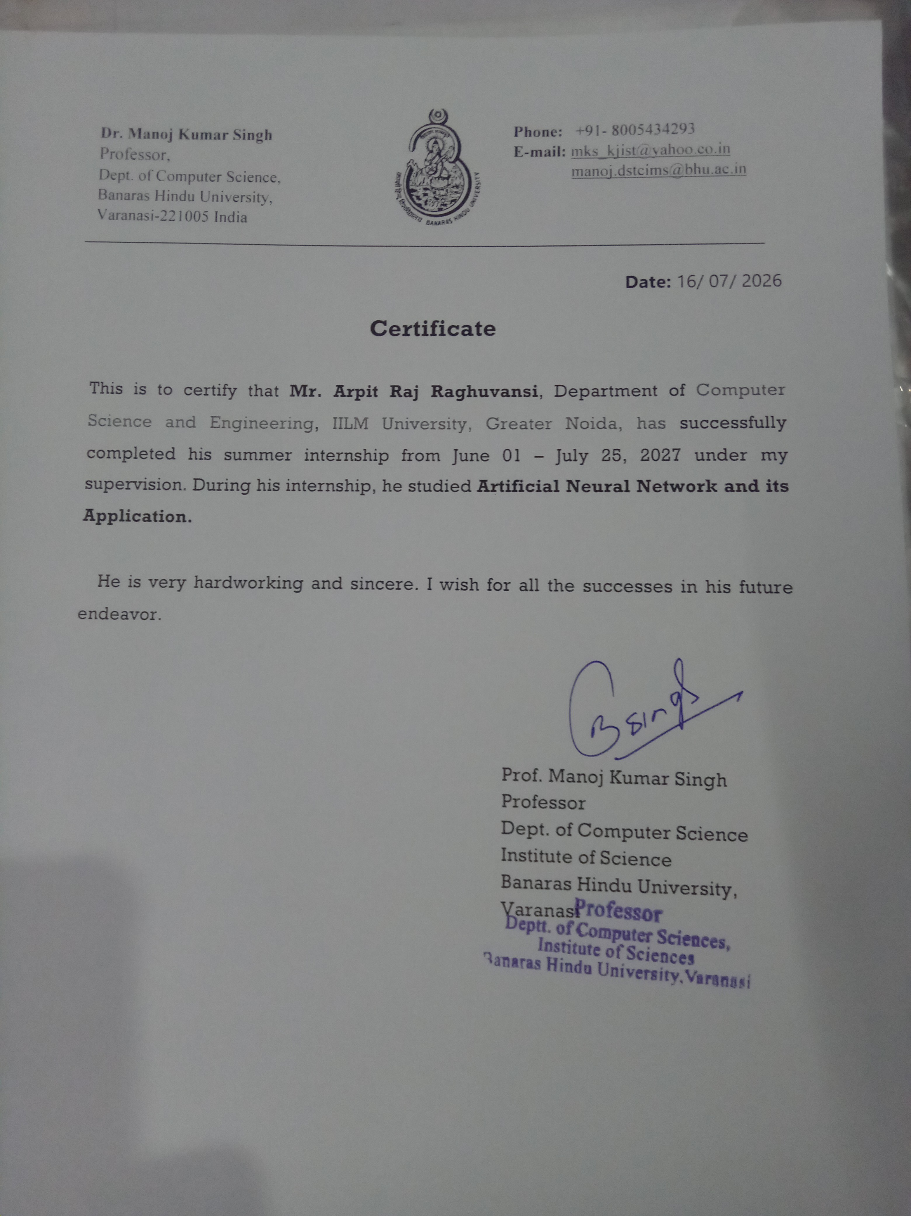

TABLE OF CONTENTS
Chapter No. | Chapter Name | Page No.
 | Cover Page | ---
1. | Candidate's Declaration | i
2. | Acknowledgement | ii
3. | Internship Completion Certificate | iii
4. | Project Description
 | 4.1 Introduction | 1
 | 4.2 Organization Profile | 1
 | 4.3 Problem Statement | 2
 | 4.4 Project Objectives | 2
 | 4.5 Scope of the Project | 3
 | 4.6 Technologies and Tools Used | 3
 | 4.7 System Architecture | 4
 | 4.8 Methodology | 4
 | 4.9 Expected Outcomes | 5
 | 4.10 Certificates of Completion | 5
5. | Bibliography / References | 7

4.1 Introduction
In today's technology-driven world, Artificial Intelligence (AI) and Machine Learning (ML) have become central to solving problems that traditional rule-based programming finds difficult — particularly tasks involving pattern recognition, prediction, and decision-making from complex data. Among the many techniques developed within this field, Artificial Neural Networks (ANNs) stand out as one of the most influential, forming the foundation of modern deep learning systems.
This report documents the work carried out during an 8-week summer research internship at the Department of Computer Science, Institute of Science, Banaras Hindu University (BHU), Varanasi, under the supervision of Prof. Manoj Kumar Singh, from June 1 to July 25, 2026. The internship focused on the topic “Artificial Neural Network and its Application”, covering the theoretical foundations of ANNs as well as their practical implementation and real-world relevance.
An Artificial Neural Network is a computational model loosely inspired by the structure and functioning of the human brain. It is composed of layers of interconnected nodes (neurons) that process information and learn patterns directly from data, rather than following explicitly programmed rules. Because of this ability to learn and generalize, ANNs are widely applied in areas such as image recognition, natural language processing, predictive analytics, healthcare, and autonomous systems.
This internship provided an opportunity to study ANN theory in depth, understand the mathematics behind how such networks learn, and gain hands-on programming experience by implementing the core concepts using Python.

4.2 Organization Profile
Banaras Hindu University (BHU), established in 1916, is one of the largest residential central universities in Asia and among India's most prestigious institutions for higher education and research. The Department of Computer Science, under the Institute of Science, BHU, is known for its strong research culture in areas including Artificial Intelligence, Machine Learning, and Data Science.
The internship was carried out under the supervision of Prof. Manoj Kumar Singh, Professor, Department of Computer Science, Institute of Science, Banaras Hindu University, Varanasi. The research environment provided exposure to academic methodology, technical problem-solving, and guided study of core AI/ML concepts.
Field | Details
Institution | Banaras Hindu University (BHU), Varanasi
Department | Department of Computer Science, Institute of Science
Supervisor | Prof. Manoj Kumar Singh
Internship Type | Research Internship (Summer)
Duration | June 1, 2026 – July 25, 2026 (8 Weeks)
Table 4.1: Organization and Internship Details

4.3 Problem Statement
Conventional rule-based programs are effective for well-defined, structured tasks but struggle when faced with problems that involve pattern recognition, non-linear relationships, or noisy, high-dimensional real-world data. Classification and prediction problems — such as recognizing images, forecasting continuous quantities, or understanding natural language — are difficult to solve using fixed, hand-written rules because the underlying relationships between inputs and outputs are too complex to specify explicitly.
The problem addressed during this internship was to study how Artificial Neural Networks, inspired by the learning mechanism of the human brain, can be used to automatically learn such patterns directly from data, and to implement a working ANN model that demonstrates this learning process end-to-end — from raw input to a trained, predictive output.

4.4 Project Objectives
- To understand the theoretical foundation of Artificial Neural Networks and their biological inspiration.
- To study the architecture of ANNs, including neurons, layers, weights, and biases.
- To implement a feed-forward neural network from scratch using Python.
- To train the model using forward propagation and backpropagation with gradient descent.
- To evaluate the performance of the trained model using appropriate metrics and visualizations.
- To explore and document real-world applications of ANNs across various domains.

4.5 Scope of the Project
The scope of this internship was primarily academic and research-oriented, focused on building a strong conceptual and practical understanding of Artificial Neural Networks rather than deploying a production-grade system. The work covered the mathematical foundations of ANNs (linear algebra and calculus underlying forward and backward propagation), implementation of a basic feed-forward network using Python and NumPy, training and evaluation on a structured dataset, and a survey of how ANN concepts extend to advanced applications such as image recognition, predictive systems, and natural language processing.
The project did not extend into large-scale deep learning frameworks (such as TensorFlow or PyTorch) or production deployment, as the emphasis was on understanding the underlying mechanics of neural networks at a foundational level.

4.6 Technologies and Tools Used
Tool / Technology | Purpose
Python | Core programming language used for implementation
NumPy | Matrix operations, weight initialization, and numerical computation
Pandas | Loading, cleaning, and structuring the dataset
Matplotlib | Visualizing training loss and accuracy curves
Jupyter Notebook | Interactive development and experimentation
VS Code | Script writing, debugging, and version control
Table 4.2: Technologies and Tools Used

4.7 System Architecture
The system implemented during the internship follows a standard feed-forward Artificial Neural Network architecture, consisting of an input layer, one or more hidden layers, and an output layer. Each layer is composed of interconnected neurons; every connection carries a learnable weight, and each neuron applies an activation function to introduce non-linearity into the model.
Component | Description
Input Layer | Receives the feature values (x₁, x₂, ... , xₙ) from the dataset
Hidden Layer(s) | Learns intermediate representations / patterns from the input
Output Layer | Produces the final prediction (class label or numeric value)
Weights & Biases | Learnable parameters adjusted during training
Activation Function | Introduces non-linearity (Sigmoid, ReLU, Tanh)
Table 4.3: Components of the ANN Architecture
Data flows forward through the network during prediction (forward propagation), and error signals flow backward through the same structure during training (backpropagation) to update weights and improve accuracy over successive iterations (epochs).

4.8 Methodology

Step 1: Data Collection
A labelled dataset suitable for a classification task was gathered as the basis for training and evaluating the network.

Step 2: Data Preprocessing
The dataset was cleaned, missing values were handled, and features were normalized using Pandas and NumPy to prepare it for training.

Step 3: Model Design
A feed-forward ANN was designed, defining the number of input, hidden, and output neurons and selecting suitable activation functions for each layer.

Step 4: Forward Propagation
Input data was passed through the network layer by layer; each neuron computed a weighted sum of its inputs and applied an activation function to produce its output.

Step 5: Training (Backpropagation)
The error between predicted and actual output was calculated using a loss function. This error was propagated backward through the network, and gradient descent was used to update the weights so as to minimize the loss.

Step 6: Evaluation
The trained model's accuracy and loss were measured, and training progress was visualized using Matplotlib to confirm that the network was learning effectively.

4.9 Expected Outcomes
The internship was expected to, and did, result in the following outcomes:
- A clear conceptual understanding of how Artificial Neural Networks learn from data.
- A working implementation of a feed-forward neural network trained using backpropagation.
- Observable improvement in model accuracy and reduction in loss across training epochs, confirming correct learning behavior.
- Practical experience with the Python data-science stack (NumPy, Pandas, Matplotlib).
- An understanding of how ANN concepts apply to real-world domains such as image recognition, predictive analytics, and conversational AI.

Applications of Artificial Neural Networks
Beyond the scope of this internship, ANNs have broad real-world applications, including:
Domain | Example Application
Image & Pattern Recognition | Facial emotion detection, object and handwriting recognition
Predictive Systems | Forecasting continuous values such as Air Quality Index (AQI) or demand
Natural Language Processing | Chatbots and conversational assistants
Healthcare | Assisting diagnosis and medical guidance systems
Finance | Fraud detection and stock trend prediction
Autonomous Systems | Perception and decision-making in self-driving vehicles and robotics
Table 4.4: Real-World Applications of Artificial Neural Networks

4.10 Certificates of Completion and Other Communication
The Internship Completion Certificate issued by Prof. Manoj Kumar Singh, Department of Computer Science, Institute of Science, Banaras Hindu University, has been attached in the front matter of this report (see “Internship Completion Certificate”). It certifies the successful completion of the internship on the topic “Artificial Neural Network and its Application” under his supervision.

5. Bibliography / References
[1] S. Haykin, Neural Networks and Learning Machines, 3rd ed., Pearson Education, 2009.
[2] I. Goodfellow, Y. Bengio, and A. Courville, Deep Learning, MIT Press, 2016.
[3] M. Nielsen, Neural Networks and Deep Learning, Determination Press, 2015.
[4] T. M. Mitchell, Machine Learning, McGraw-Hill Education, 1997.
[5] D. E. Rumelhart, G. E. Hinton, and R. J. Williams, “Learning representations by back-propagating errors,” Nature, vol. 323, pp. 533–536, 1986.
[6] Official NumPy Documentation, https://numpy.org/doc/
[7] Official Pandas Documentation, https://pandas.pydata.org/docs/
[8] Official Matplotlib Documentation, https://matplotlib.org/stable/index.html

